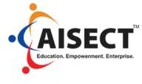

Certification in Cyber Security (C- CS)

3 Months | Extensive Learning | Live Projects & Case Studies | E-labs & Simulators

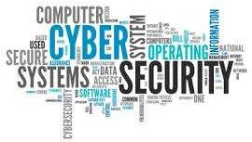
“As cybersecurity leaders, we have to create our message of influence because security is a culture and you need the business to take place and be part of that security culture.” — Britney Hommertzheim, Director, Information Security, AMC Theatres, at SecureWorld Kansas City

CAREER OPPRTUNITIES IN CYBER SECURITY

Chief Information Security Officer
- Forensic Computer Analyst
- Information Security Analyst
- Penetration Tester
- Security Architect
- IT Security Engineer
- Security Systems Administrator
- IT Security Consultant

UNIQUE PROGRAMME FEATURES

  - The platform supports project based learning

  - The platform offers e-Labs with which the student/candidate can practice the basics of technology

  - Industry mentors who can guide the students and candidates through individual sessions

  - Live interactions with Machine Learning experts and Corporate leaders

  - e-learning activities with Case studies, Live-projects, and Assignments
PROGRAMME TAKEAWAY
    - End-to-End Security Management
    - Risk Assessment
    - Software Application Security
    - Database Security
    - Cryptography Algorithms and Protocols
    - Malware
    - Network Threats and Defenses
    - Web Security
    - Mobile Security
    - Legal and Ethical Issues and Privacy

WHAT WILL YOU LEARN
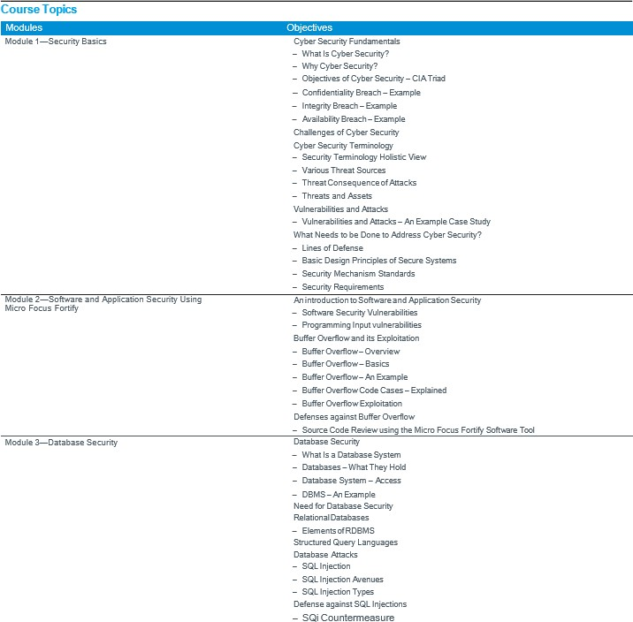

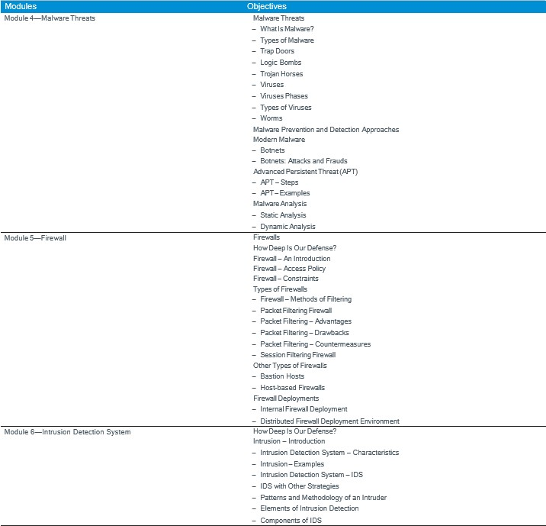
WHAT WILL YOU LEARN

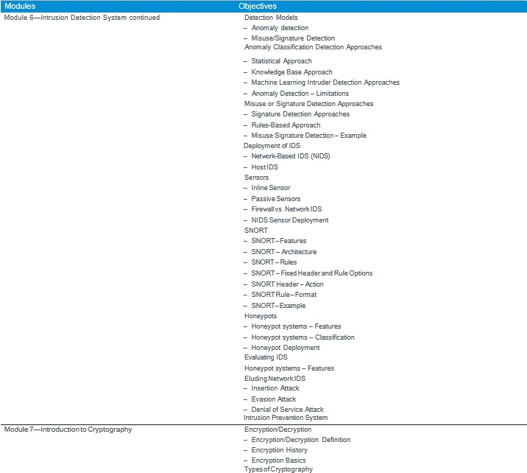
WHAT WILL YOU LEARN

WHAT WILL YOU LEARN
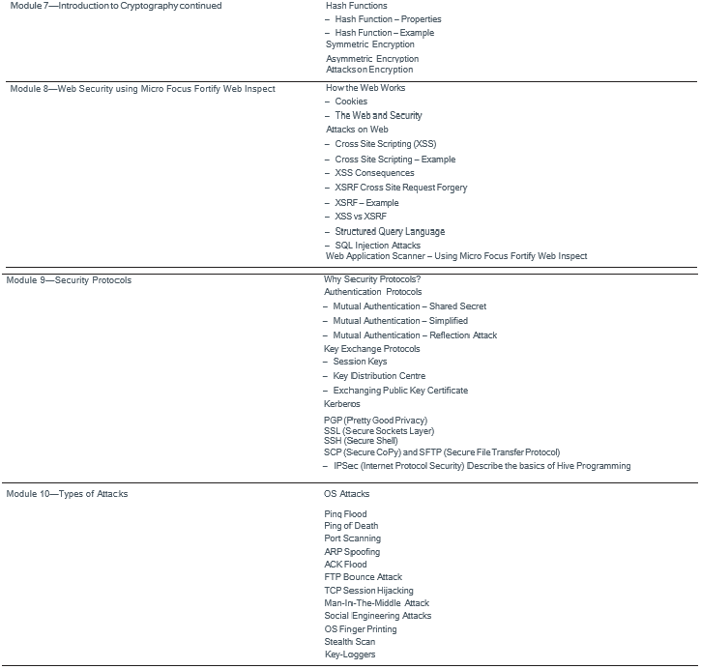

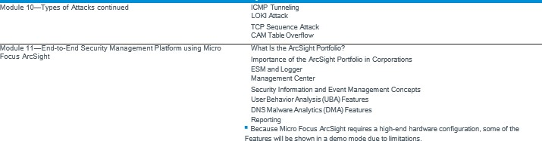
WHAT WILL YOU LEARN

In addition to the Micro Focus software tools, this course also covers demonstrations and
labs using the following freeware:

- CentOS GUI ■ XVWA tool
- LAMP stack – Linux/Apache/Mysql/PHP ■ NMAP on Linux
- Burpsuite portswigger ■ NJRAT (Trojan)
- DVWA tool ■ CRYTTOOLS

C ert i f i cat i on in M a c h i n e L e a r n i n g &A r t i f i c i a l I n t e l l i g e n c e (C - M L & A I)

Email Us: rajat@aisect.org anandkarajagi@aisect.org

